Week 15
Problem Statement:
Given an array of integers, reverse the given array in place using an index and loop rather
than a built-in function.
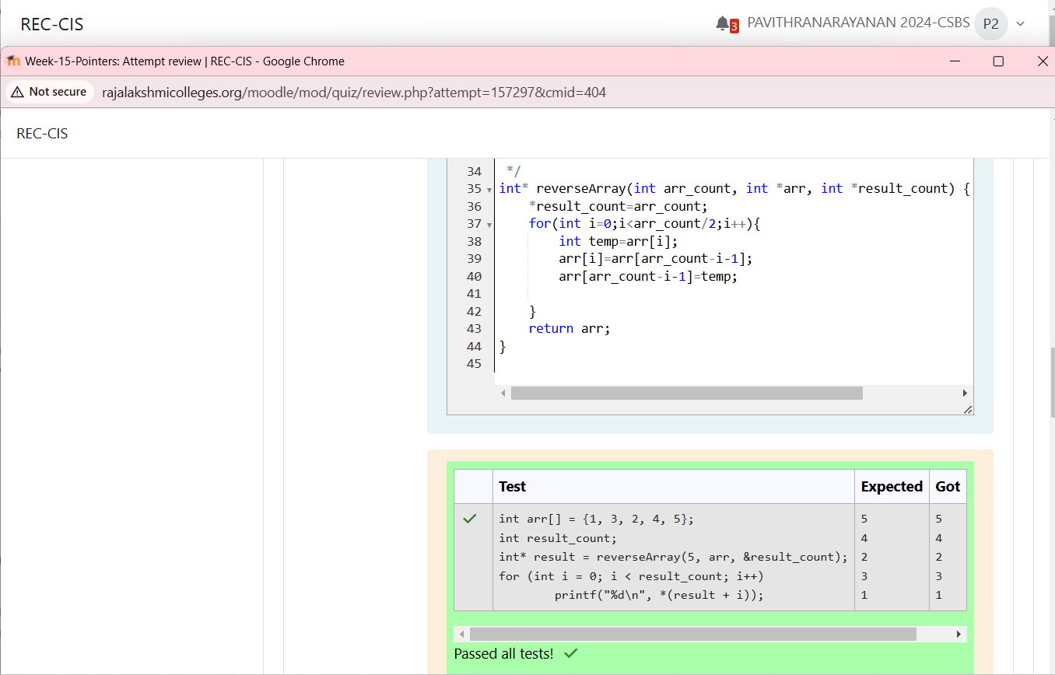
Problem Statement:
An automated cutting machine is used to cut rods into segments. The cutting machine can
only hold a rod of minLength or more, and it can only make one cut at a time. Given the
array lengths [] representing the desired lengths of each segment, determine if it is
possible to make the necessary cuts using this machine. The rod is marked into lengths
already, in the order given.
